FULL ADDER USING NAND GATES

AIM: To implement the full adder using nand gates through logicism.

INPUT:

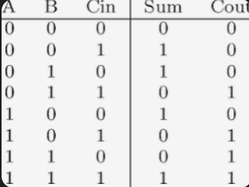

OUTPUT:

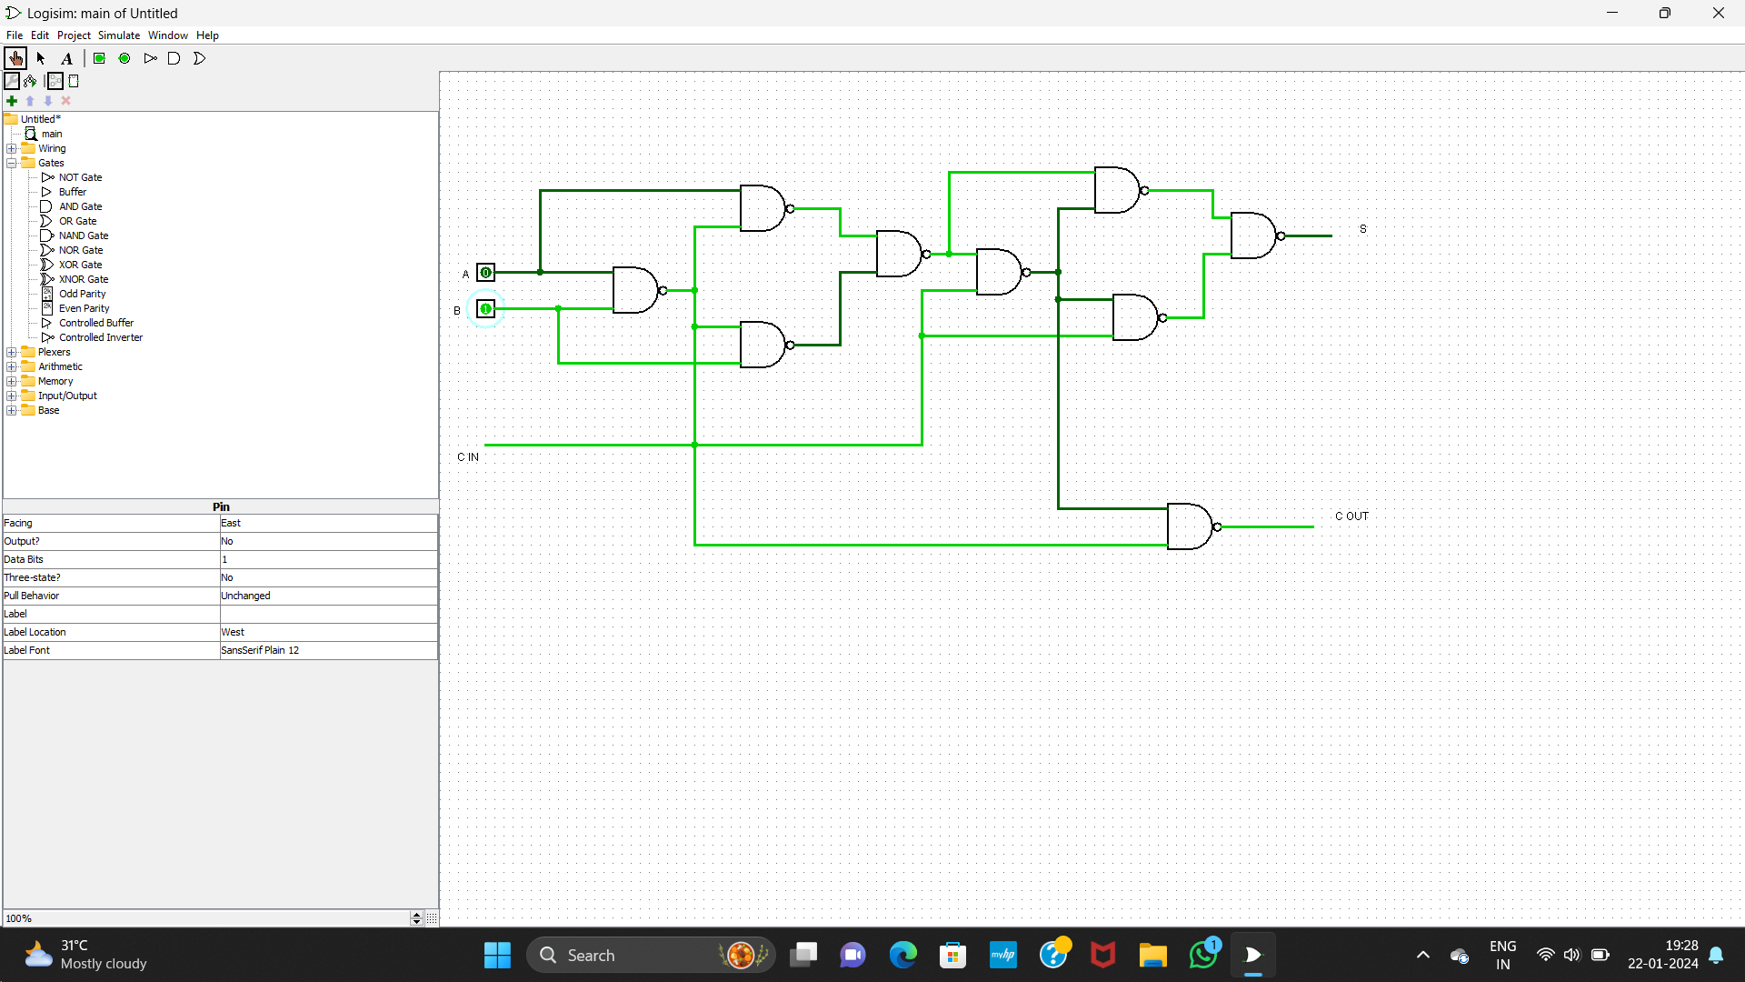

RESULT: Thus the program was executed successfully using logic sim.